SOC Simulation:-
SIEM used – Splunk
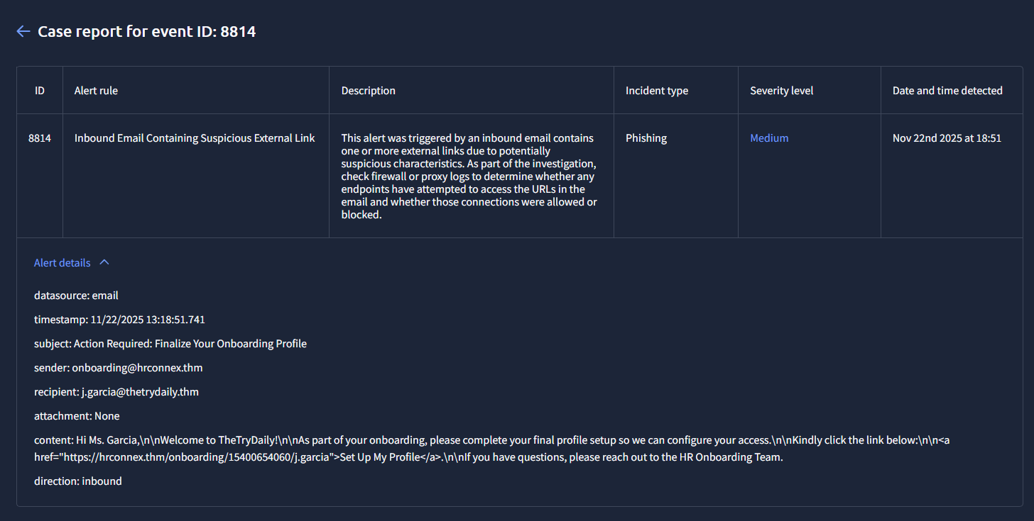
This were the details of the first alert that came in. So first step was to take ownership of the alert and either tag it as a false positive(not genuine) or a true positive( may be actually harmful)
So we use Splunk as the SIEM tool to investigate previous cases in which the same email may have been blocked/not blocked or if the domain of the link in the alert was accessed/blocked by any clients. Upon searching through splunk for the domain name of the link:
index=* "hrconnex.thm"

The alerts were filtered down to the following 3:
1 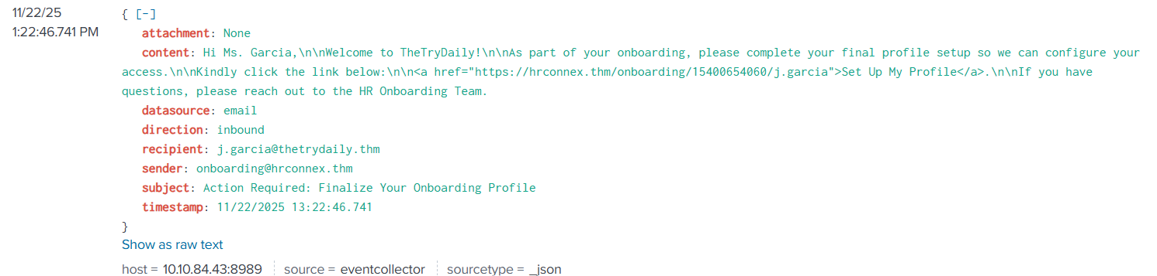
2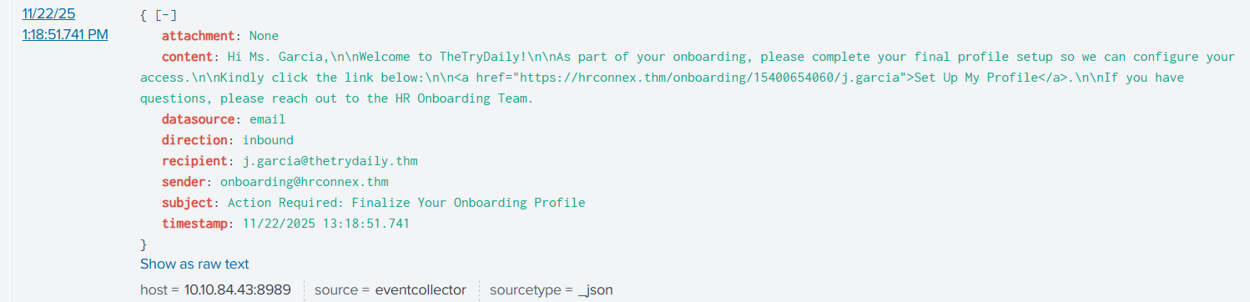
3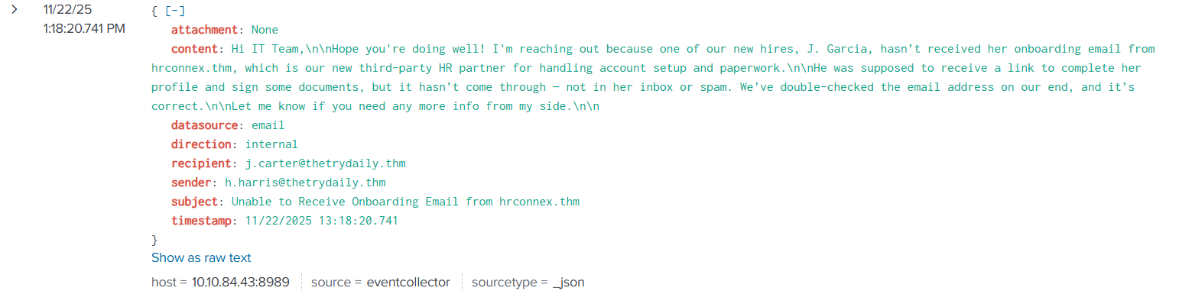

From the third attempt it becomes clear that the link and emails were genuinely sent by an employee/collegue and were legitimate. So can be flagged as a false positive(not risky)
Case Report -
Time of Activity:
Nov 22nd 2025 at 18:51
List of Related Entities:
- Recipient: j.garcia@thetrydaily.thm
- Sender: onboarding@hrconnex.thm
- Subject: "Action Required: Finalize Your Onboarding Profile"
- Suspicious URL: https://hrconnex.thm/onboarding/15400654060/j.garcia
- Domain: hrconnex.thm
- Attachment: None
Reason for Classifying as False Positive:
The email security tool flagged the message because it contains an external link from an unfamiliar domain. However, internal HR communications confirm that hrconnex.thm is a newly onboarded third-party HR vendor, and the onboarding email was expected. No malicious activity was detected, and the domain is legitimate.
Next:-
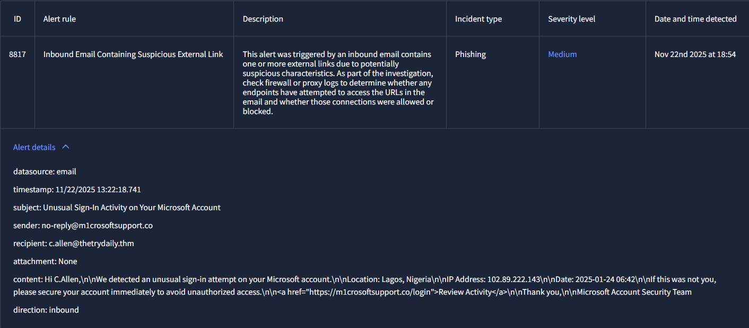
Now this is a clear case of domain spoofing. Going through SIEM logs, to further investigate the same domain, following logs came up:
1
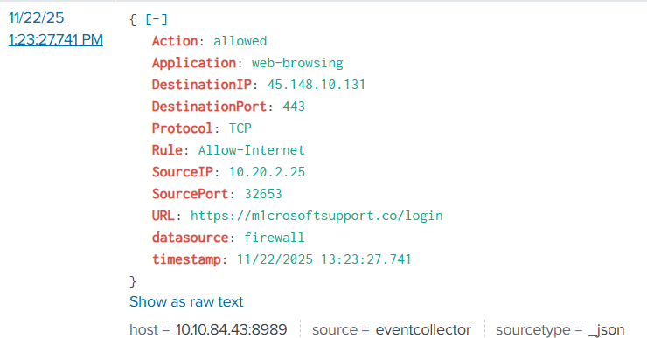
2
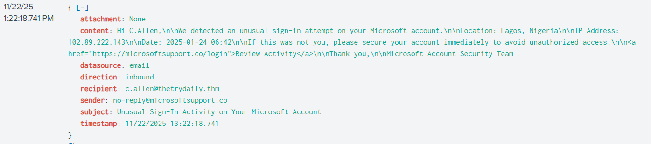
So we can see that the victim definitely clicked on the link that was sent to his email. The IP of the domain was external/outside the organisation so that also raises suspicions. It also had an urgency to it which may have tricked the user into clicking the link. As the traffic from this link was not blocked and the user connected to the URL successfully, it is necessary to further escalate and investigate this alert. So it is a true positive.
Case report –
Time of activity:
Nov 22nd 2025 at 18:54
List of Affected Entities:
c.allen@thetrydaily.thm
Reason for Classifying as True Positive:
Domain name is clearly spoofed(Instead of microsoft, m1crosoftsupport) has been used.
Reason for Escalating the Alert:
The alert is escalated because the recipient (c.allen@thetrydaily.thm) clicked a link to a suspicious domain (m1crosoftsupport.co) identified as a Microsoft account phishing attempt. Firewall logs confirm the connection was allowed, indicating potential exposure of credentials or compromise of the endpoint. Escalation is required for
Recommended Remediation Actions:
Password reset, endpoint review, blocking the domain
List of Attack Indicators:
Spoofed domain, external IP, traffic was allowed

Next: -
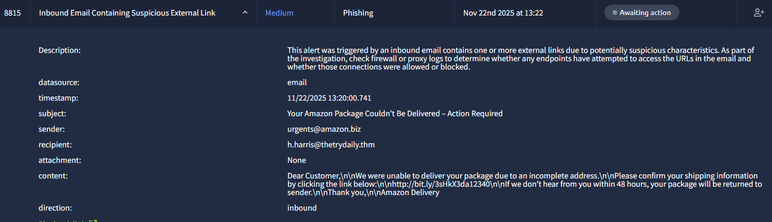
Upon going through SIEM logs following 2 came up: -
1
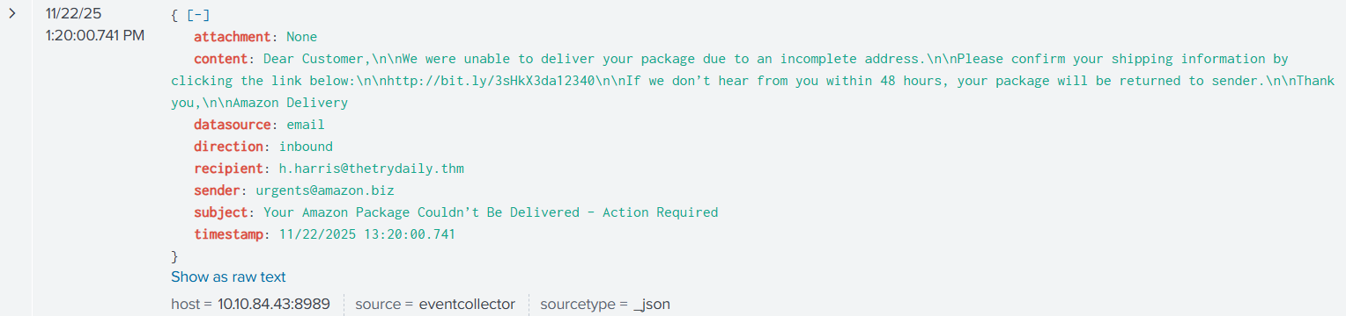
2
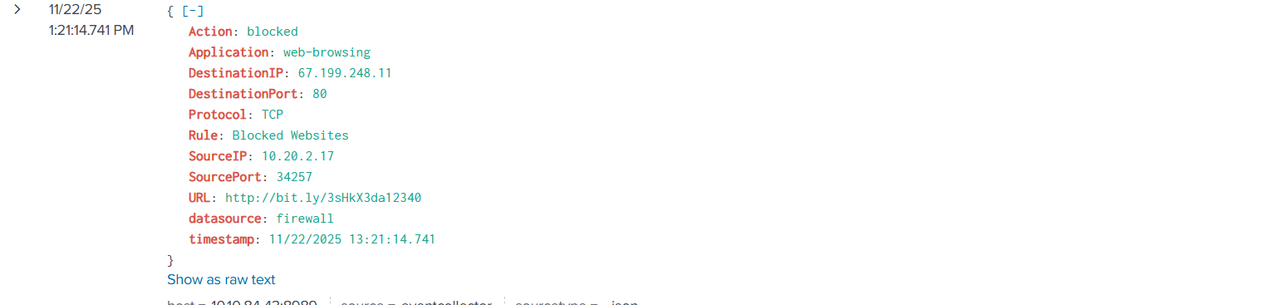
Second log shows us that the user actually clicked on the link and the link was blocked . So this means that the attempt was a phishing attempt as the website was maliciously flagged by the organization.
Also other indicators such as – shortened URL, a tone of urgency in the email, unreliable email domain name also indicate a phishing attempt. So we will be flagging this as a true positive.
Case Report –
Time of activity:
Nov 22nd 2025 at 18:52
List of Affected Entities:
h.harris@thetrydaily.thm
Reason for Classifying as True Positive:
Shortened URL, Website has been blocked, Tone of urgency in email content
Reason for Escalating the Alert:
The alert is escalated because the recipient attempted to access the malicious URL, which could have led to credential theft or compromise if not blocked. Escalation ensures higher-level SOC analysts or IT security staff can review the endpoint, update threat intelligence, and apply user education to prevent future incidents.
Recommended Remediation Actions:
- Block the malicious URL (http://bit.ly/3sHkX3da12340) at firewall and proxy.
- Verify that the endpoint (IP 10.20.2.17) is free from malware or compromise.
- Inform and educate the user about the phishing attempt.
- Add the sender domain (amazon.biz) to email filtering and threat intelligence blocklists.
- Monitor for additional phishing attempts targeting other users.
List of Attack Indicators:
- Shortened URL: http://bit.ly/3sHkX3da12340
- Firewall blocked access to the website
- Email tone of urgency / social engineering content
- Suspicious sender domain: urgents@amazon.biz
- Targeted recipient: h.harris@thetrydaily.thm
Shortened URL, Website has been blocked, Tone of urgency in email content

Next-
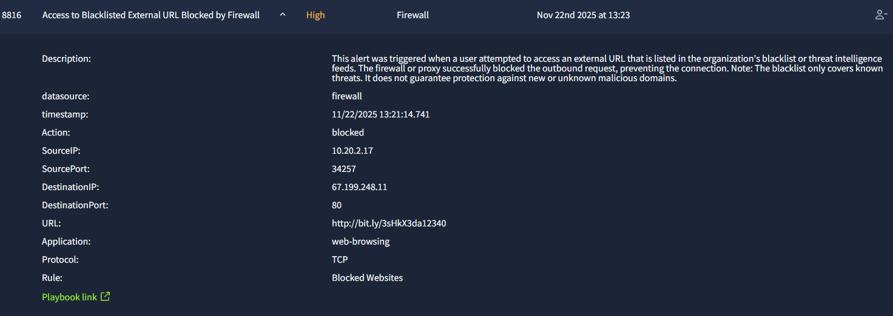
Now this alert is just a result of the previous email phishing attempt, as this alert suggests that the user actually clicked on the link.
Case report –
Time of activity:
Nov 22nd 2025 at 18:53
List of Affected Entities:
10.20.2.17
Reason for Classifying as True Positive:
The alert is classified as a True Positive because the user attempted to access a known malicious URL (http://bit.ly/3sHkX3da12340) that is listed in the organization's blacklist. Firewall logs confirm that the access was blocked, preventing potential compromise.
Reason for Escalating the Alert:
The alert is escalated because the user attempted to access a high-risk URL. Even though the firewall blocked the connection, there is a potential risk of credential theft or endpoint compromise. Escalation allows SOC analysts or IT security staff to verify the endpoint, ensure no further threats exist, and provide user awareness guidance.
Recommended Remediation Actions:
- Block the URL in all web filters and proxy logs to prevent future attempts.
- Verify the endpoint (IP 10.20.2.17) is not compromised.
- Educate the user about phishing attempts and safe browsing practices.
- Monitor the firewall/proxy logs for repeated attempts or similar URLs.
- Add the domain to threat intelligence blocklists for proactive protection.
List of Attack Indicators:
External IP, shortened URL, sent by an unreliably domained email

Next –
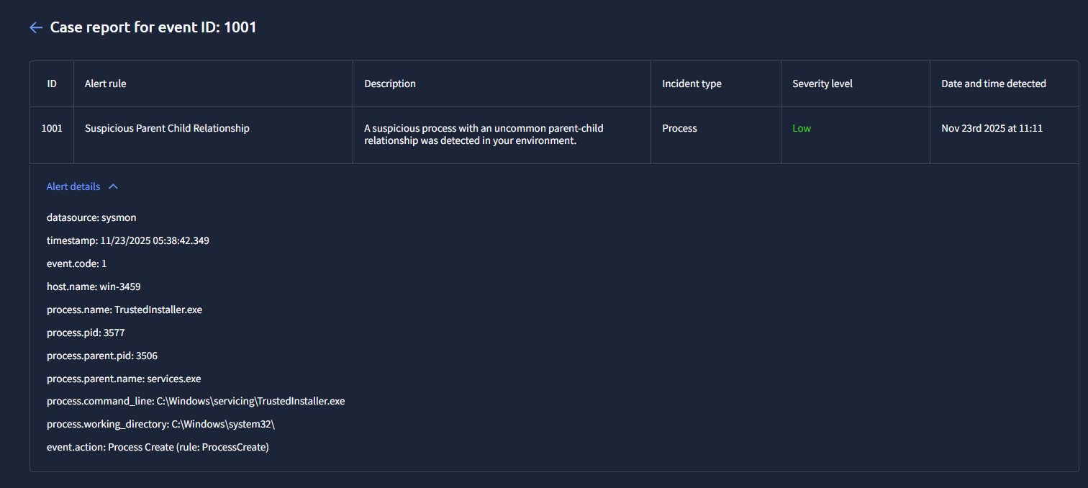
✅ Reason for Classifying as False Positive
The alert was triggered due to an uncommon parent–child process relationship involving services.exe and TrustedInstaller.exe. After investigation, the activity was determined to be legitimate Windows behavior rather than malicious. TrustedInstaller.exe is the Windows Modules Installer responsible for servicing operations such as Windows Updates and component installation. It is normally launched and managed by services.exe, the Service Control Manager.
Verification steps confirmed that:
- File paths matched default Windows locations (C:\Windows\servicing\TrustedInstaller.exe and C:\Windows\System32\services.exe).
- Digital signatures were valid and signed by Microsoft, ruling out tampering or impersonation.
- No abnormal child processes, registry modifications, or network connections were observed associated with TrustedInstaller.exe.
- Windows servicing logs showed normal component or update-related activity around the alert timestamp.
Since no signs of malicious behavior, persistence, or lateral movement were identified, this process creation event is consistent with legitimate system maintenance activity. Therefore, the detection is classified as a false positive.
WHAT IS SUSPICIOUS PARENT CHILD RELATIONSHIP?
It is when an ongoing process creates/spawns/accesses another process for its execution. So in this case process with PID 3506(parent) running services.exe spawns a process 3577(child) running TrustedInstaller.exe.
NEXT-
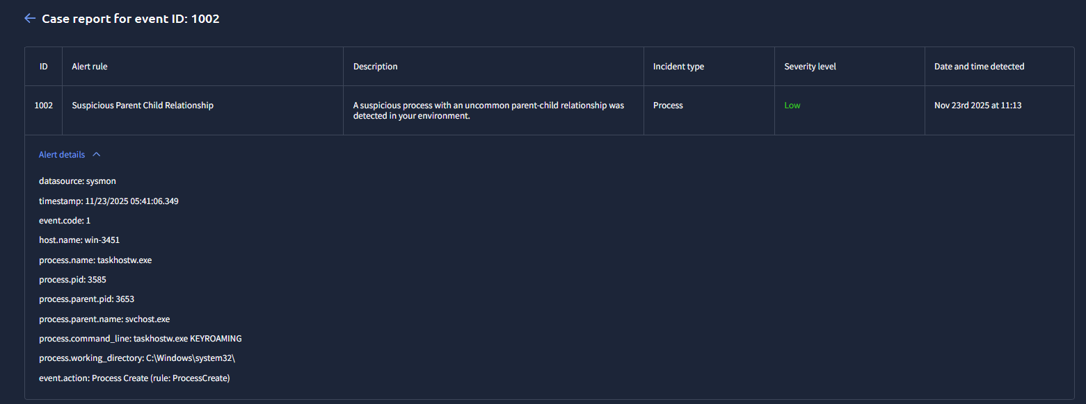
False positive case report : -
Time of Activity:
11/23/2025 05:41:06.349
List of Related Entities:
host.name: win-3451
process.name: taskhostw.exe
process.pid: 3585
process.parent.pid: 3653
process.parent.name: svchost.exe
process.command_line: taskhostw.exe KEYROAMING (keyroaming parameter is used to synchronize keys and certificates)
Reason for Classifying as False Positive:
Process relationship is common.
svchost(service host) is used to manage system services) is running taskhostw.exe(task scheduler) which is common.
So after doing this, the question may arise, IS ANY CHILD FROM PARENT svchost(service host) a common relationship, and can be ignore easily? The answer is no.
No, you cannot assume that any child process created by svchost.exe is always safe. Many child processes under svchost.exe are legitimate, but not all of them.
What svchost.exe normally does
svchost.exe (Service Host) runs a large number of legitimate Windows services such as Windows Update, DNS Client, DHCP, Windows Defender, and other background system functions. In normal operation, it can legitimately create child processes like:
rundll32.exe
dllhost.exe
taskhostw.exe
conhost.exe
audiodg.exe
These are usually normal relationships.
Why you cannot assume it is always safe
Attackers frequently abuse svchost.exe. Malware may inject code into svchost.exe or use it to spawn malicious child processes in an attempt to appear legitimate. This means svchost.exe can also be involved in malicious activity.
Examples of suspicious child processes include:
powershell.exe
cmd.exe
wscript.exe
mshta.exe
Any executable running from uncommon paths such as user folders, temp folders, or downloads
Any unsigned or unknown executable launched by svchost.exe
These relationships are generally not normal and should be investigated.
Summary
Most svchost.exe child processes are normal because it hosts many Windows services. However, you should not assume they are always safe. The safety depends entirely on which child process is being launched and from where.

Now in the following case:-
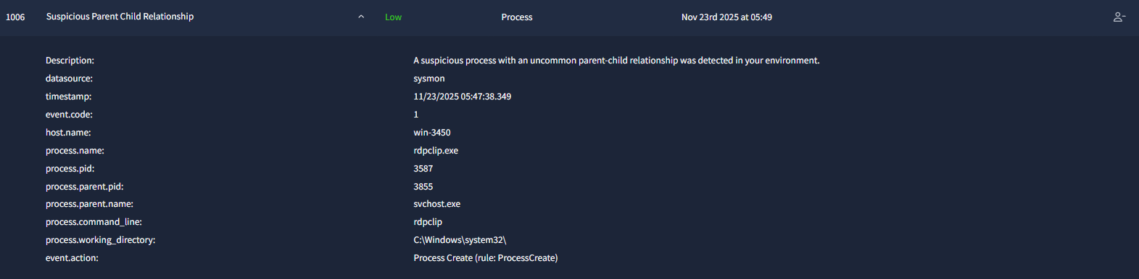
So the service host has spawned a child process using rdpclip.exe. But rdpclip.exe is a legitimate process.
rdpclip.exe is a legitimate Windows process that manages the clipboard for Remote Desktop sessions, allowing users to copy and paste text, files, and other data between their local computer and a remote computer. It synchronizes the clipboard contents, enabling seamless data transfer between the two machines. If this process stops working, copy-paste functionality will fail, and it can be restarted by ending the task in Task Manager and creating a new one.
Hence, naturally, this is a false positive. Case report :-
Time of Activity:
11/23/2025 05:47:38.349
List of Related Entities:
host.name: win-3450
process.name: rdpclip.exe
process.pid: 3587
process.parent.pid: 3855
process.parent.name: svchost.exe
process.command_line: rdpclip
process.working_directory: C:\Windows\system32\
Reason for Classifying as False Positive:
Process relationship is common.rdpclip.exe is a legitimate Windows process that manages the clipboard for Remote Desktop sessions, allowing users to copy and paste text, files, and other data between their local computer and a remote computer. So it can be spawned by the service host.
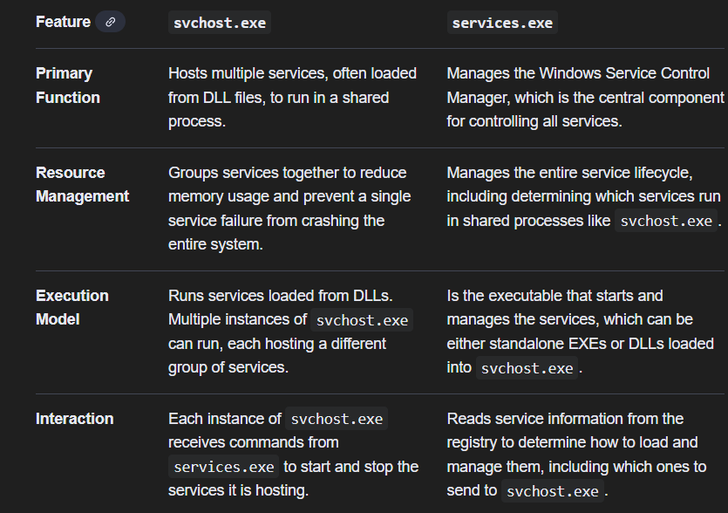
Above shows how services.exe and svchost.exe are different.

NEXT –
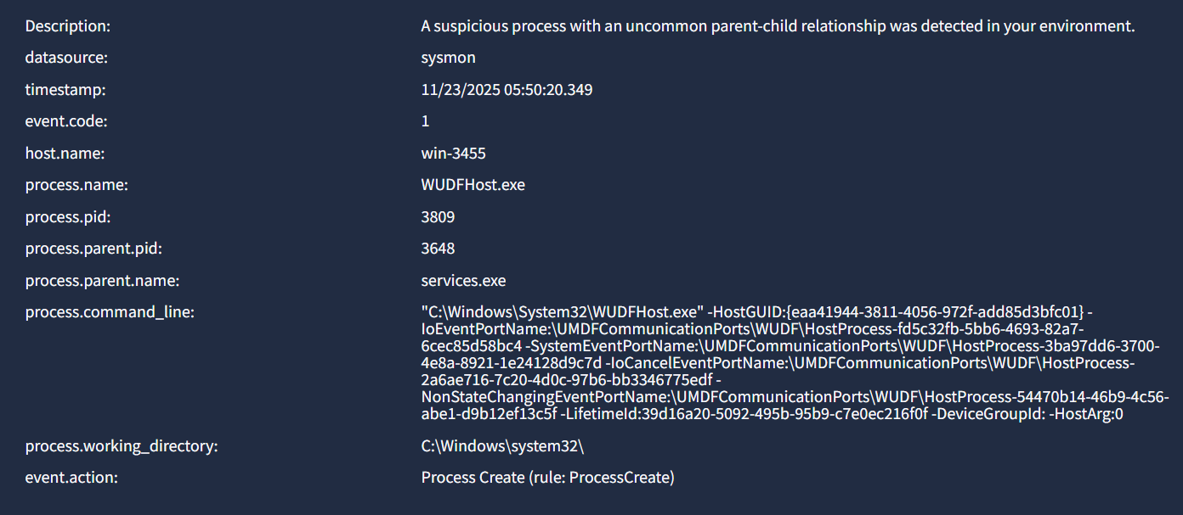
wudfhost.exe is a legitimate and essential Windows process called the Windows User-Mode Driver Framework Host Service. It is responsible for running and managing hardware drivers in "user mode," which increases system stability by isolating them from the core operating system. This process is safe and necessary for your computer's hardware, such as keyboards, USB devices, and webcams, to function correctly.
Wudfhost.exe (User-mode Driver Framework Host Process) is a child process of the driver manager service, which runs within services.exe.
So relationship is common. Case report –
Time of Activity:
11/23/2025 05:54:24.349
List of Related Entities:
event.code: 1
host.name: win-3455
process.name: WUDFHost.exe
process.pid: 3710
process.parent.pid: 3817
process.parent.name: services.exe
process.command_line: "C:\Windows\System32\WUDFHost.exe" -HostGUID:{24b7eef1-ada5-453b-a5a6-93007dca6fbc} -IoEventPortName:\UMDFCommunicationPorts\WUDF\HostProcess-fd5c32fb-5bb6-4693-82a7-6cec85d58bc4 -SystemEventPortName:\UMDFCommunicationPorts\WUDF\HostProcess-3ba97dd6-3700-4e8a-8921-1e24128d9c7d -IoCancelEventPortName:\UMDFCommunicationPorts\WUDF\HostProcess-2a6ae716-7c20-4d0c-97b6-bb3346775edf -NonStateChangingEventPortName:\UMDFCommunicationPorts\WUDF\HostProcess-54470b14-46b9-4c56-abe1-d9b12ef13c5f -LifetimeId:39d16a20-5092-495b-95b9-c7e0ec216f0f -DeviceGroupId: -HostArg:0
process.working_directory: C:\Windows\system32\
Reason for Classifying as False Positive:
Wudfhost.exe (User-mode Driver Framework Host Process) can be a child process of the driver manager service, which runs within services.exe. So process relationship is common.
NEXT –
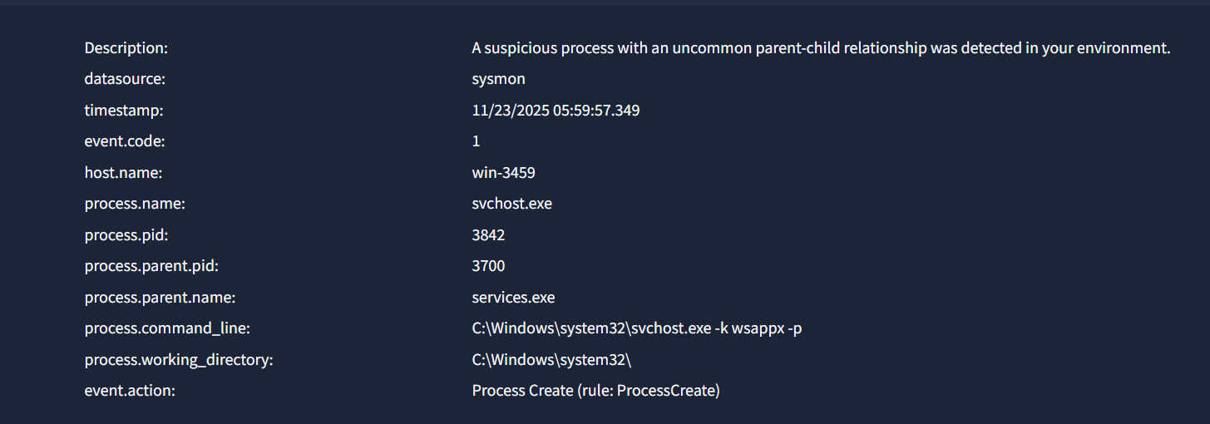
Again a common relationship.
- Process details
Child process: svchost.exe
Parent process: services.exe
Command line: C:\Windows\system32\svchost.exe -k wsappx -p
Working directory: C:\Windows\system32\
- What this means
services.exe is the Windows Service Control Manager.
svchost.exe is the generic host process that runs Windows services.
The command line:
svchost.exe -k wsappx -p
indicates that this instance of svchost.exe is running the "wsappx" service group.
- What wsappx is
wsappx is a legitimate Windows service container.
It includes two services:
- AppX Deployment Service (AppXSVC)
- Client License Service (ClipSVC)
These services handle Windows Store app installations, updates, licensing, and related infrastructure.
wsappx commonly consumes CPU during app installation, updates, or background maintenance.
- Is this normal?
Yes.
services.exe launching svchost.exe with a service group parameter (-k wsappx) is standard Windows behavior.
- Why the alert fired
The SIEM flagged it because wsappx does not run constantly, so the parent-child relationship may appear "uncommon."
However, this behavior is completely normal for Windows and is not associated with malicious activity.
- Final conclusion
This is a false positive.
services.exe → svchost.exe with "-k wsappx" is normal Windows service initialization.
NEXT –
1. Process details
Child process: taskhostw.exe
Parent process: svchost.exe
Command line: taskhostw.exe NGCKeyPregen
Working directory: C:\Windows\system32\
2. What taskhostw.exe is
taskhostw.exe is a legitimate Windows process called “Host Process for Windows Tasks.”
Its purpose is to load and execute DLL-based tasks and background components.
It is normal for taskhostw.exe to appear with different arguments depending on the task being run.
3. What “NGCKeyPregen” means
NGCKeyPregen refers to “Next-Generation Credentials Key Pre-generation.”
This is part of Windows Hello and Windows authentication infrastructure.
It is responsible for generating or refreshing keys used for:
- Windows Hello PIN
- Biometrics
- Credential protection
- User authentication keys
- Secure login mechanisms
This task runs in the background and is usually triggered by Windows authentication services.
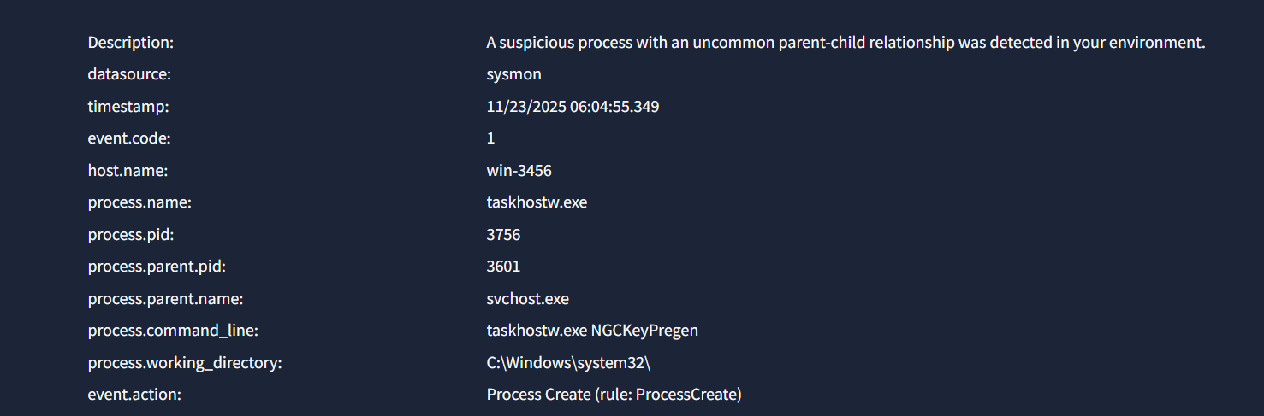
So it is a false positive.
NEXT –
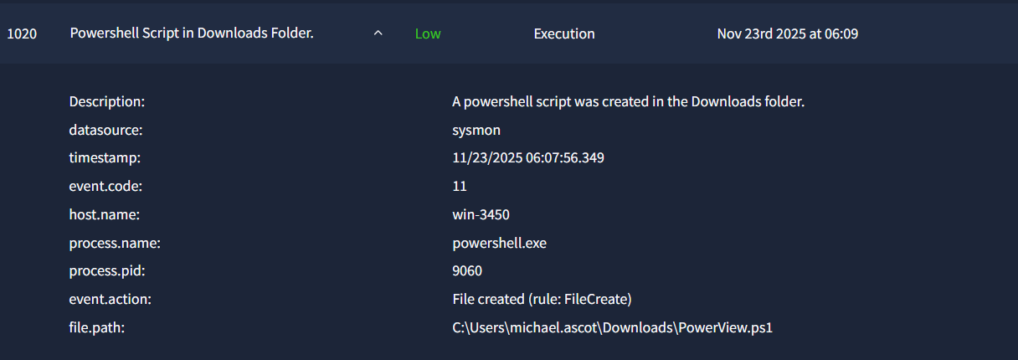
Now a user creating a powershell executable file on his PC raises suspicion as it may not be him but instead someone else executing malicious scripts. So upon going through SIEM events we find out that it is actually executing a remote script.
PowerView.ps1 is a well-known post-exploitation / AD reconnaissance script used in PowerShell Empire and by red-teamers/attackers after gaining access.
Upon searching in event logs the following script was found :-
{"datasource":"powershell","timestamp":"11/23/2025 06:09:35.913","file.path":"C:\\Users\\michael.ascot\\downloads\\PowerView.ps1","event.action":"Execute a Remote Command","powershell.file.script_block_text":" } else { # otherwise, get the local machine context Write-Verbose \"Adding user $UserName to $GroupName on localhost\" $Context = New-Object System.DirectoryServices.AccountManagement.PrincipalContext([System.DirectoryServices.AccountManagement.ContextType]::Machine, $Env:ComputerName) } # find the particular group $Group = [System.DirectoryServices.AccountManagement.GroupPrincipal]::FindByIdentity($Context,$GroupName) # add the particular user to the group $Group.Members.add($Context, [System.DirectoryServices.AccountManagement.IdentityType]::SamAccountName, $UserName) # commit the changes $Group.Save() } catch { Write-Warning \"Error adding $UserName to $GroupName : $_\" } }}function Get-UserProperty {<# .SYNOPSIS Returns a list of all user object properties. If a property name is specified, it returns all [user:property] values. Taken directly from @obscuresec's post: http://obscuresecurity.blogspot.com/2014/04/ADSISearcher.html .PARAMETER Properties Property names to extract for users. .PARAMETER Domain The domain to query for user properties, defaults to the current domain. .PARAMETER DomainController Domain controller to reflect LDAP queries through. .PARAMETER PageSize The PageSize to set for the LDAP searcher object. .EXAMPLE PS C:\\> Get-UserProperty -Domain testing Returns all user properties for users in the 'testing' domain. .EXAMPLE PS C:\\> Get-UserProperty -Properties ssn,lastlogon,location Returns all an array of user/ssn/lastlogin/location combinations for users in the current domain. .LINK http://obscuresecurity.blogspot.com/2014/04/ADSISearcher.html#> [CmdletBinding()] param( [String[]] $Properties, [String] $Domain, [String] $DomainController, [ValidateRange(1,10000)] [Int] $PageSize = 200 ) if($Properties) { # extract out the set of all properties for each object $Properties = ,\"name\" + $Properties Get-NetUser -Domain $Domain -DomainController $DomainController -PageSize $PageSize | Select-Object -Property $Properties } else { # extract out just the property names Get-NetUser -Domain $Domain -DomainController $DomainController -PageSize $PageSize | Select-Object -First 1 | Get-Member -MemberType *Property | Select-Object -Property 'Name' }}function Find-UserField {<# .SYNOPSIS Searches user object fields for a given word (default *pass*). Default field being searched is 'description'. Taken directly from @obscuresec's post: http://obscuresecurity.blogspot.com/2014/04/ADSISearcher.html .PARAMETER SearchTerm Term to search for, default of \"pass\". .PARAMETER SearchField User field to search, default of \"description\". .PARAMETER ADSpath The LDAP source to search through, e.g. \"LDAP://OU=secret,DC=testlab,DC=local\" Useful for OU queries. .PARAMETER Domain Domain to search computer fields for, defaults to the current domain. .PARAMETER DomainController Domain controller to reflect LDAP queries through. .PARAMETER PageSize The PageSize to set for the LDAP searcher object. .EXAMPLE PS C:\\> Find-UserField -SearchField info -SearchTerm backup Find user accounts with \"backup\" in the \"info\" field.#> [CmdletBinding()] param( [Parameter(Position=0,ValueFromPipeline=$True)] [String] $SearchTerm = 'pass', [String] $SearchField = 'description', [String] $ADSpath, [String] $Domain, [String] $DomainController, [ValidateRange(1,10000)] [Int] $PageSize = 200 ) process { Get-NetUser -ADSpath $ADSpath -Domain $Domain -DomainController $DomainController -Filter \"($SearchField=*$SearchTerm*)\" -PageSize $PageSize | Select-Object samaccountname,$SearchField }}function Get-UserEvent {<# .SYNOPSIS Dump and parse security events relating to an account logon (ID 4624) or a TGT request event (ID 4768). Intended to be used and tested on Windows 2008 Domain Controllers. Admin Reqd? YES Author: @sixdub .PARAMETER ComputerName The computer to get events from. Default: Localhost .PARAMETER EventType Either 'logon', 'tgt', or 'all'. Defaults: 'logon' .PARAMETER DateStart Filter out all events before this date. Default: 5 days .EXAMPLE PS C:\\> Get-UserEvent -ComputerName DomainController.testlab.local .LINK http://www.sixdub.net/2014/11/07/offensive-event-parsing-bringing-home-trophies/#> Param( [String] $ComputerName = $Env:ComputerName, [String] [ValidateSet(\"logon\",\"tgt\",\"all\")] $EventType = \"logon\", [DateTime] $DateStart=[DateTime]::Today.AddDays(-5) ) if($EventType.ToLower() -like \"logon\") { [Int32[]]$ID = @(4624) } elseif($EventType.ToLower() -like \"tgt\") { [Int32[]]$ID = @(4768) } else { [Int32[]]$ID = @(4624, 4768) } #grab all events matching our filter for the specified host Get-WinEvent -ComputerName $ComputerName -FilterHashTable @{ LogName = 'Security'; ID=$ID; StartTime=$DateStart} -ErrorAction SilentlyContinue | ForEach-Object { if($ID -contains 4624) { # first parse and check the logon event type. This could be later adapted and tested for RDP logons (type 10) if($_.message -match '(?s)(?<=Logon Type:).*?(?=(Impersonation Level:|New Logon:))') { if($Matches) { $LogonType = $Matches[0].trim() $Matches = $Null } } else { $LogonType = \"\" } # interactive logons or domain logons if (($LogonType -eq 2) -or ($LogonType -eq 3)) { try { # parse and store the account used and the address they came from if($_.message -match '(?s)(?<=New Logon:).*?(?=Process Information:)') { if($Matches) { $UserName = $Matches[0].split(\"`n\")[2].split(\":\")[1].trim() $Domain = $Matches[0].split(\"`n\")[3].split(\":\")[1].trim() $Matches = $Null } } if($_.message -match '(?s)(?<=Network Information:).*?(?=Source Port:)') { if($Matches) { $Address = $Matches[0].split(\"`n\")[2].split(\":\")[1].trim() $Matches = $Null } } # only add if there was account information not for a machine or anonymous logon if ($UserName -and (-not $UserName.endsWith('$')) -and ($UserName -ne 'ANONYMOUS LOGON')) { $LogonEventProperties = @{ 'Domain' = $Domain 'ComputerName' = $ComputerName 'Username' = $UserName 'Address' = $Address 'ID' = '4624' 'LogonType' = $LogonType 'Time' = $_.TimeCreated } New-Object -TypeName PSObject -Property $LogonEventProperties } } catch { Write-Debug \"Error parsing event logs: $_\" } } } if($ID -contains 4768) { # the TGT event type try { if($_.message -match '(?s)(?<=Account Information:).*?(?=Service Information:)') { if($Matches) { $Username = $Matches[0].split(\"`n\")[1].split(\":\")[1].trim() $Domain = $Matches[0].split(\"`n\")[2].split(\":\")[1].trim() $Matches = $Null } } if($_.message -match '(?s)(?<=Network Information:).*?(?=Additional Information:)') { if($Matches) { $Address = $Matches[0].split(\"`n\")[1].split(\":\")[-1].trim() $Matches = $Null } } $LogonEventProperties = @{ 'Domain' = $Domain 'ComputerName' = $ComputerName 'Username' = $UserName 'Address' = $Address 'ID' = '4768' 'LogonType' = '' 'Time' = $_.TimeCreated } New-Object -TypeName PSObject -Property $LogonEventProperties } catch { Write-Debug \"Error parsing event logs: $_\" } } }}function Get-ObjectAcl {<# .SYNOPSIS Returns the ACLs associated with a specific active directory object. Thanks Sean Metcalf (@pyrotek3) for the idea and guidance. .PARAMETER SamAccountName Object name to filter for. .PARAMETER Name Object name to filter for. .PARAMETER DistinguishedName Object distinguished name to filter for. .PARAMETER ResolveGUIDs Switch. Resolve GUIDs to their display names. .PARAMETER Filter A customized ldap filter string to use, e.g. \"(description=*admin*)\" .PARAMETER ADSpath
THIS SCRIPT IS MALICIOUS
PowerView is NOT a legitimate Windows script
It is part of PowerSploit, a well-known post-exploitation / attack toolkit used by:
- Red teams
- Penetration testers
- Actual attackers
No normal admin uses PowerView for routine work. Microsoft does not ship this.
The commands inside the script do things like:
🔸 Enumerating domain users (Get-NetUser)
🔸 Enumerating ACLs (Get-ObjectACL)
🔸 Parsing logons (Get-UserEvent)
🔸 Searching for passwords in AD fields (Find-UserField)
🔸 Adding users to local groups (the snippet you posted earlier!)
These are classic post-exploitation actions after gaining initial access.
SO IT IS A TRUE POSITIVE. CASE REPORT –
Time of activity:
11/23/2025 06:07:56.349
List of Affected Entities:
event.code: 11
host.name: win-3450
process.name: powershell.exe
process.pid: 9060
event.action: File created (rule: FileCreate)
file.path: C:\Users\michael.ascot\Downloads\PowerView.ps1
Reason for Classifying as True Positive:
PowerView script being executed has malicious code.
Reason for Escalating the Alert:
Must be responded to immediately or organization network may be compromised
Recommended Remediation Actions:
User endpoint check, password reset
List of Attack Indicators:
PowerView Script
Has malicious code being executed
NEXT –
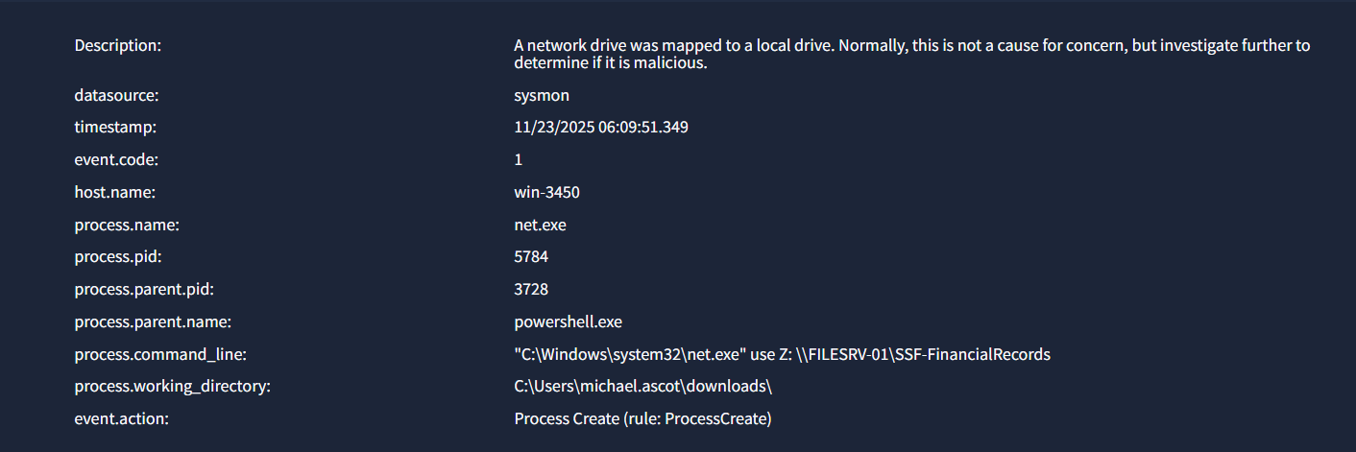
What this basically means is that another user/machine is attempting to connect to the victim machine to access and operate with files on his machines. Now within an organisation this may be common. But we just previously saw a PowerView script created on the victims PC and in this alert the parent process is powershell and the child is net.exe. Also the commandline shows that the external machine/user may be attempting to access Financial Records which may be normal but still suspicious. So we search through event logs for net.exe. These events come up:-
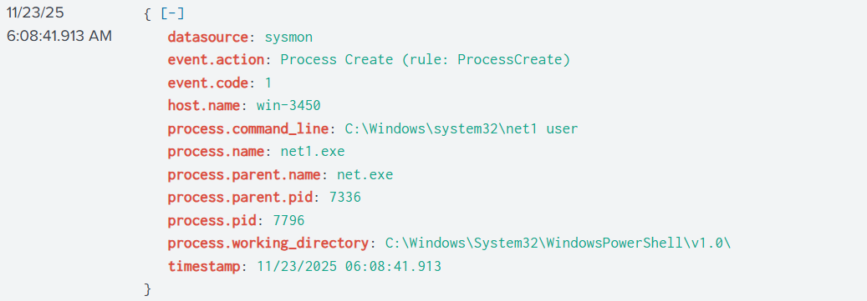
Attacker is carrying out reconnaisance by listing out all users by executing the net1 script which is a child of net.exe to identify accounts to compromise.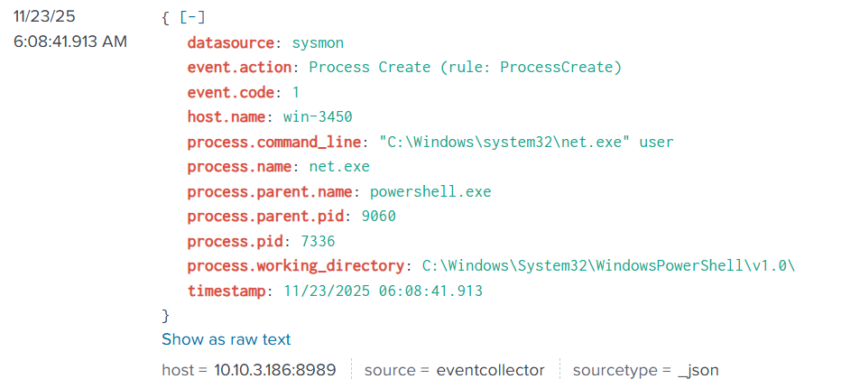 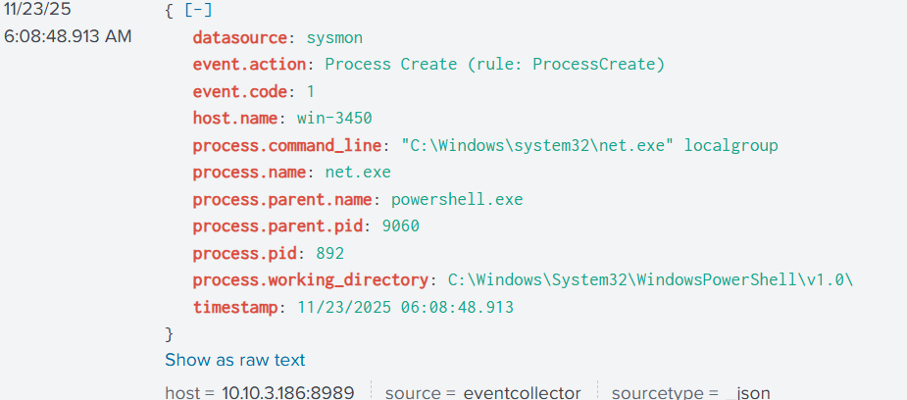 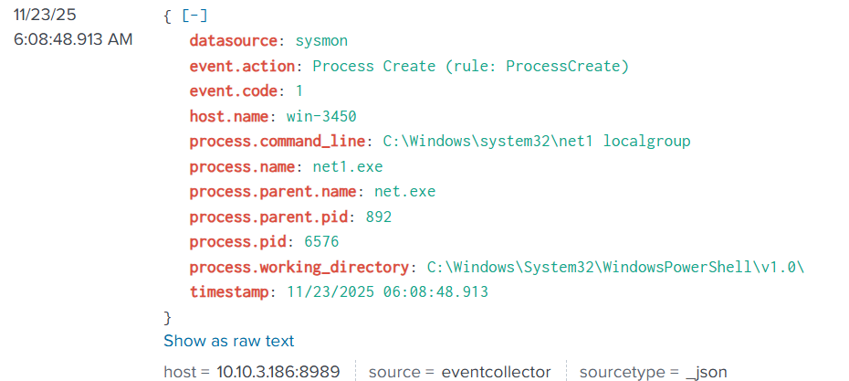
net1 localgroup
Meaning:
- Attacker is listing all local groups on the system:
  - Administrators
  - Remote Desktop Users
  - Backup Operators
  - etc.
Intent:
Identify high-privilege groups they may try to add themselves to.
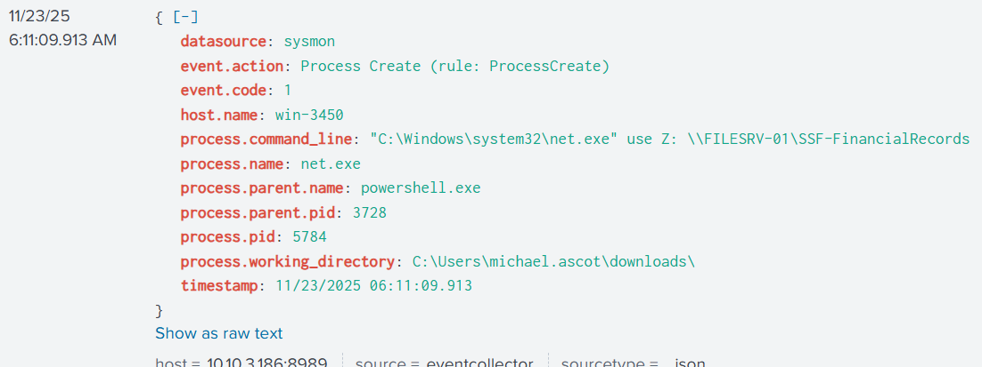
Attacker mapped his drive to the local drive to access financial records of the organization.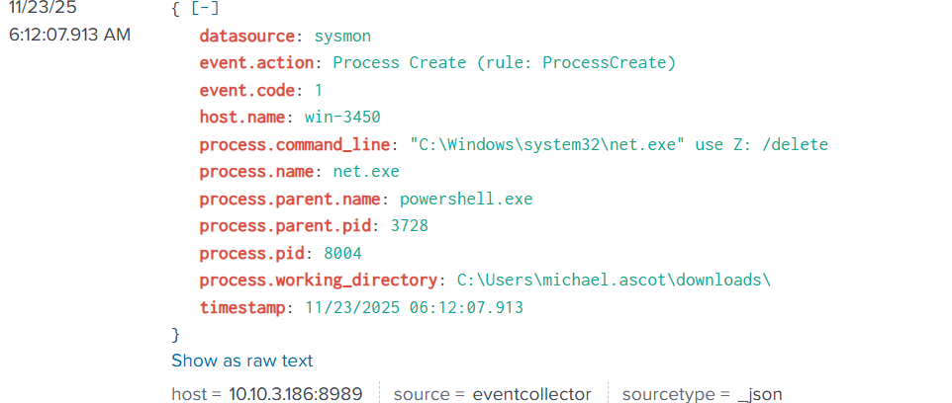
The attacker immediately deletes the drive mapping to cleanup his traces and avoid detection.
SO THIS IS A TRUE POSITIVE –
CASE REPORT –
Time of activity:
11/23/2025 06:09:51.349
List of Affected Entities:
event.code: 1
host.name: win-3450
process.name: net.exe
process.pid: 5784
process.parent.pid: 3728
process.parent.name: powershell.exe
process.command_line: "C:\Windows\system32\net.exe" use Z: \\FILESRV-01\SSF-FinancialRecords
process.working_directory: C:\Users\michael.ascot\downloads\
Reason for Classifying as True Positive:
Malicious script was executed on the same endpoint, which mapped a network drive to the local drive and tried to access financial records of the organisation. Drive connections were also promptly deleted which raises suspicion.
Reason for Escalating the Alert:
User endpoint may be compromised
Recommended Remediation Actions:
Endpoint check,password reset, etc.
List of Attack Indicators:
Malicious script was executed on the same endpoint, which mapped a network drive to the local drive and tried to access financial records of the organisation. Drive connections were also promptly deleted which raises suspicion.
NEXT –
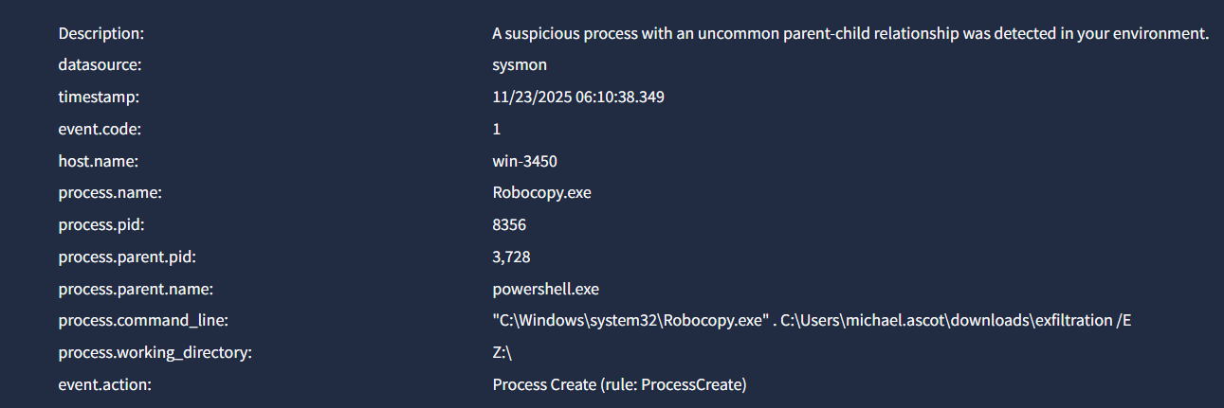
Exfiltration is the unauthorized transfer of data from a computer or network to an external location, commonly known as data theft. It can also refer to the secretive removal of military personnel from a hostile area. In a cybersecurity context, this process can involve malware, phishing, or exploiting vulnerabilities to steal sensitive information like intellectual property or personal data.
Robocopy.exe - robocopy.exe is a command-line utility in Windows for robustly copying files and directories. Also known as "Robust File Copy," it is more powerful than basic commands like COPY or XCOPY and includes features like resuming interrupted transfers, mirroring directories, and copying security permissions. It is built into modern Windows versions and is often used for tasks like backing up large amounts of data.
So the execution of a powershell script(which may be PowerView1.ps) is spawning a robocopy process which is copying data into a file named exifiltration?
Very smart hacker
This was done 3 times :
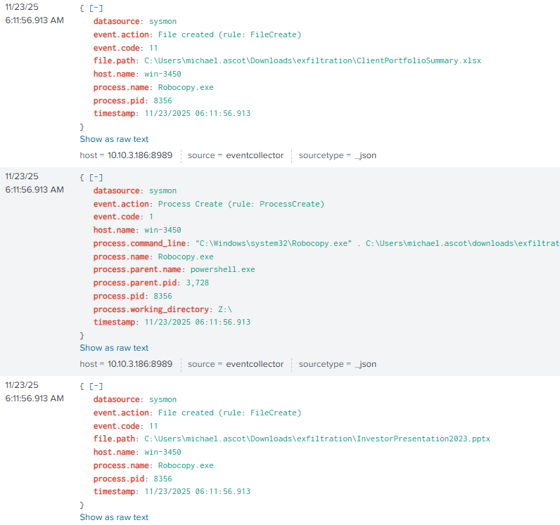
So it is a TRUE POSITIVE
NEXT –
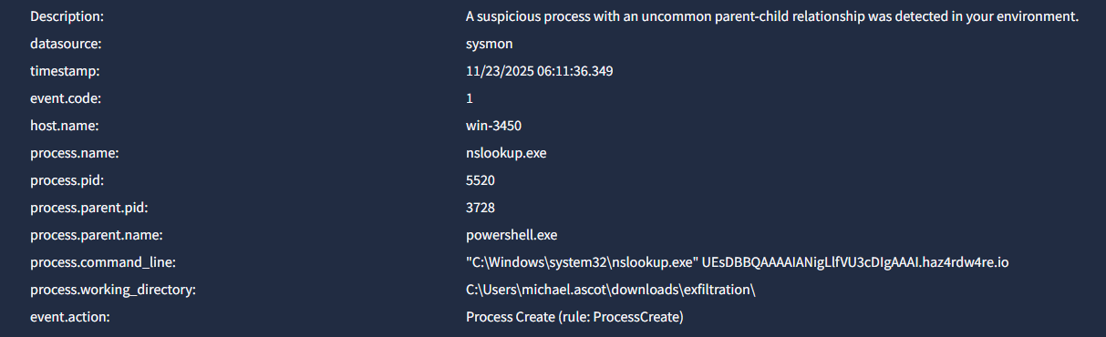
nslookup.exe is the genuine executable file for the nslookup command-line utility in Microsoft Windows, used to query Domain Name System (DNS) servers to resolve domain names to IP addresses and other DNS records. It is a critical component for network troubleshooting and is not a virus, but a legitimate system file that should not be disabled.
MULTIPLE such alerts have come up. But what does it actually mean?
Attackers are using nslookup.exe as a data exfiltration tool.
This is not normal system usage, and the command is extremely suspicious.
The string being looked up:
UEsDBBQAAAAIANigLlfVU3cDIgAAAI.haz4rdw4re.io
This is not a real hostname.
The prefix UEsDBBQ... looks like Base64 or ZIP header data, not a domain name.
Attackers sometimes embed file data inside DNS queries to bypass firewalls.
This technique is known as:
DNS Exfiltration (MITRE: T1048.003)
also referred to as
DNS Tunneling
TRUE POSITIVE. CASE REPORT -
Time of activity:
11/23/2025 06:11:36.349
List of Affected Entities:
event.code: 1
host.name: win-3450
process.name: nslookup.exe
process.pid: 5520
process.parent.pid: 3728
process.parent.name: powershell.exe
process.command_line: "C:\Windows\system32\nslookup.exe" UEsDBBQAAAAIANigLlfVU3cDIgAAAI.haz4rdw4re.io
process.working_directory: C:\Users\michael.ascot\downloads\exfiltration\
Reason for Classifying as True Positive:
Parent-Child Relationship is suspicious
Reason for Escalating the Alert:
Hostname being looked up is not real. Also it is being run by a powershell script which may be due to PowerView which may be malicious.
Recommended Remediation Actions:
Block the DNS haz4rdw4re.io
Endpoint check,cleanup,isolation, password reset.
https://tryhackme.com/soc-sim/summary/69229d25cea6ccabe7ead48b
https://tryhackme.com/soc-sim/public-summary/6023e5ac4f6bff0705e014fddf3d9c0a757ee2069c0b99e9944f376f7097a6685136e1e7f03d83815cbcf9d6a42f9751

